Children’s Speech and Language Therapy Service

SPEECH SOUND SCREEN

0116 2955256

Children's Speech and Language Therapy Service Leicester, Leicestershire and Rutland | Leicestershire Partnership NHS Trust (leicspart.nhs.uk)

INTRODUCTION
It is common for children’s speech to contain immaturities as they grow.
This resource supports you in understanding when certain sounds should be developing in a child’s speech and will guide possible referrals to the Speech & Language Therapy Service.

This table outlines speech sound development norms. However, it is important to remember that all children are different:

Sound/s | Average age of acquisition
p | 2 – 3 years
End sounds in place e.g., cup, bag, mat | 3 years
b, m, n, t, d, w, h, k, g, ng, f, y, | 3 – 4 years
s, z, l, v sh, ch, j, | 4 – 5 years
Consonant blends including 3 element blends eg, sp, st, fl, spl | 5 years
zh, r | 5 – 6 years
th | 6 – 7 years
McLeod and Crowe (2018). Cross Linguistic Consonant Acquisition. American Journal of Speech and Language Pathology. 27, 1546-1571.

GUIDANCE ON USING THE SPEECH ASSESSMENT:
If you have concerns about a child’s speech development (clarity) we ask that you complete the attached speech screen. This will help to identify if they do in fact have speech sound difficulties and if a referral to the Speech & Language Therapy Service is needed.

Each picture contains one target sound. These are clearly identified on the assessment form provided e.g.,

Target sound | Initial sound |  | Medial sound |  | Final sound
p | pig |  | apple |  | cup
Point to each picture and ask the child to name it. If they are unsure try to give them clues eg, ‘it’s an animal that goes oink’. You may need to prompt them further e.g., ‘is it a pig or a chair’.
Use black ink to tick the appropriate box if the child says the word correctly e.g.

Target sound | Initial sound |  | Medial sound |  | Final sound
p | pig |  | apple |  | cup

If the child cannot say the word/s correctly, try to write down how it sounded,
as best you can e.g.,

Target sound | Initial sound |  | Medial sound |  | Final sound
p | pig | big | apple | abble | cup | cu

Please add any information you have on whether the child can accurately copy any sounds said in error (for example, if your child says “tar” for “car”, can they copy a correct “c/k” sound or say the word “car” when it is modelled by an adult?).

Once completed all the pictures compare the results with the speech norms provided which will help determine if a referral to Speech & Language Therapy is needed.

WHEN TO REFER TO SPEECH & LANGUAGE THERAPY:
If a child is under 3 years of age ensure they have adequate attention/listening, vocabulary & expressive language skills before examining their speech sounds.

If speech sounds are the only area of concern and they have good language skills, undertaking early listening and phonological awareness tasks will be very beneficial.

From 3 years onwards many sounds are establishing in a child’s speech sound systems including the consistent signalling of end sounds. It is common that f, s, k, g are problematic but these should be more accurately used by the age of 4.

Children should be able to say many sounds correctly by the age of 4+ years. However, it is common that they may still have difficulty with:
- The sounds r, l, sh, ch, j, th
- Consonant blends eg
  - ‘s’ blends eg, spoon, star, school
  - ‘r’ blends eg, brown, crown, tree
  - ‘l’ blends eg, blue, clown
- 3 element blends eg, string, splinter
Refer to Speech & Language Therapy at 4+ if the child has difficulty with any other sound than those identified above eg, p, b, t, d, k, g, f, s

Between 5 to 7 years children should be able to produce all sounds except perhaps:
r, l, th, ‘l’ blends, ‘r’ blends & 3 element blends

Refer to Speech & Language Therapy if the child has difficulty with any other sound or blend than those identified above.

OTHER RED FLAGS TO REFERRAL:
- The child is unintelligible to familiar people
- The child is frustrated and distressed by speech
- No use of initial or final sounds
- A predominance of one sound eg, five – ‘dive’, chair – ‘dair’, cat – ‘dat’, sun – ‘dun’, pig – ‘did’, shoe – ‘do’

WHEN NOT TO REFER:
- Dribbling/drooling/congestion only
- A child with a tongue tie with no eating/drinking or speech difficulties
- Lisps if adult teeth are not in place &/or child has no awareness or motivation to use a clearer ‘s’
- Accent/dialect substitutions eg, thumb = fum, thing = fing
- A child with ingrained simplifications for certain words like saying ‘yellow’ as ‘lellow’ when they can use ‘y’ in other words
- If the child is experiencing only a mild delay for their age eg, only just turned 5 years of age and not consistently using ‘s’ blends

SPEECH ASSESSMENT RECORDING SHEET
Child’s Name: DOB: Age: Completed by: Date:
Target sound  (Average age of acquisition) | Initial sound |  | Medial sound |  | Final sound
p (2-3 years) | pig |  | apple |  | cup
b (3-4 years) | ball |  | baby |  | crab
t (3-4 years) | teddy |  | button |  | hat
d (3-4 years) | dice |  | ladder |  | bird
k (3-4 years) | car |  | rocket |  | duck
g (3-4 years) | girl |  | finger |  | bag
m (3-4 years) | mouse |  | hammer |  | ice cream
n (3-4 years) | knife |  | money |  | man
f (3-4 years) | fire |  | elephant |  | leaf
v (4-5 years) | van |  | hoover |  | five
s (4-5 years) | sun |  | castle |  | house
z (4-5 years) | zebra |  | scissors |  | cheese
sh (4-5 years) | shell |  | t-shirt |  | fish
ch (4-5 years) | chair |  | kitchen |  | watch
j (4-5 years) | jam |  | fire engine |  | orange
l (4-5 years) | lion |  | balloon |  | bell
w (3-4 years) | whale |  | cobweb |  | snow
r (5-6 years) | rabbit |  | kangaroo
th (6-7 years) | thumb |  | birthday |  | bath
Consonant blends (5 years)
“s” blends | snail |  | smile |  | swing
 | star |  | spoon |  | scarf
“l” blends | blue |  | plate |  | clown
 | flower |  | glasses |  | slide
“r” blends | bread |  | present |  | frog
 | tree |  | drum |  | crown

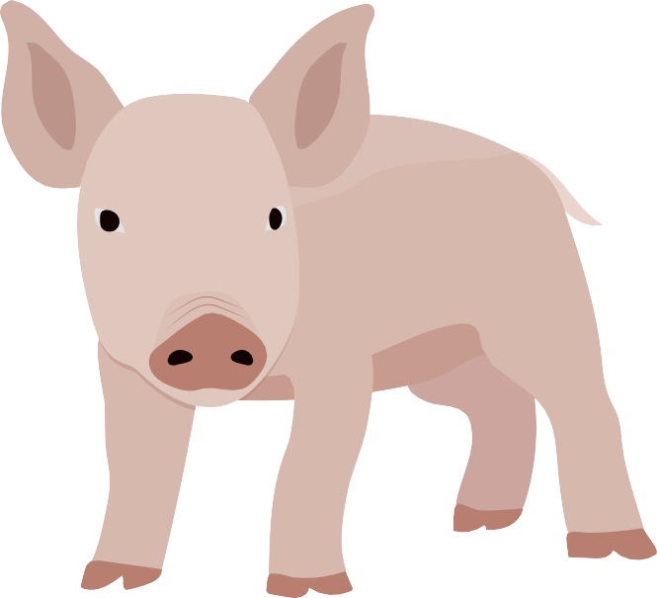
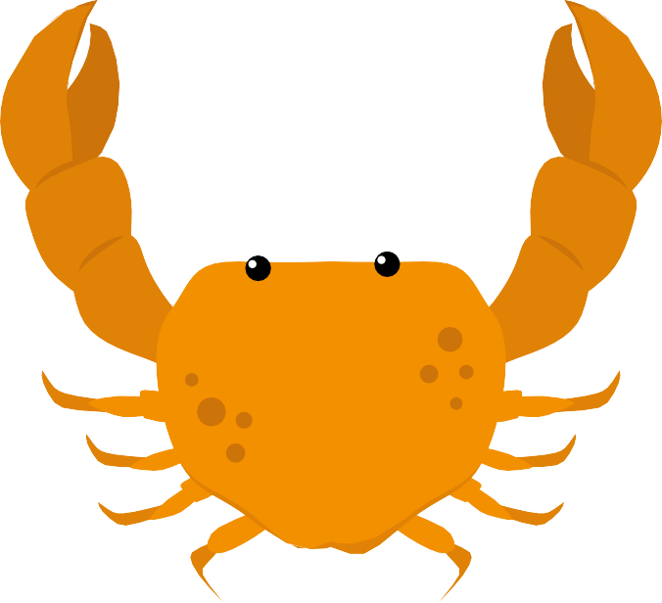

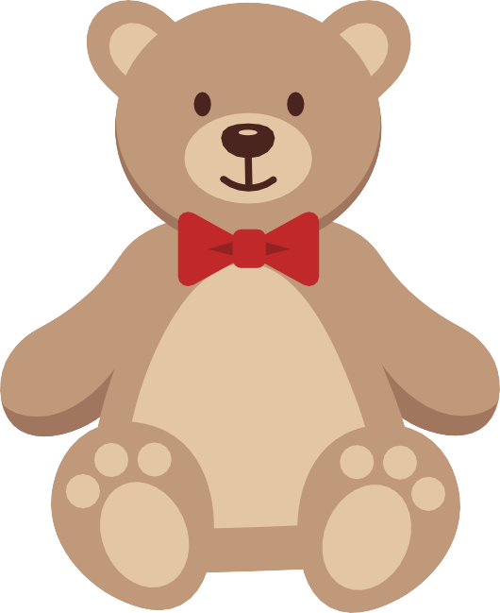

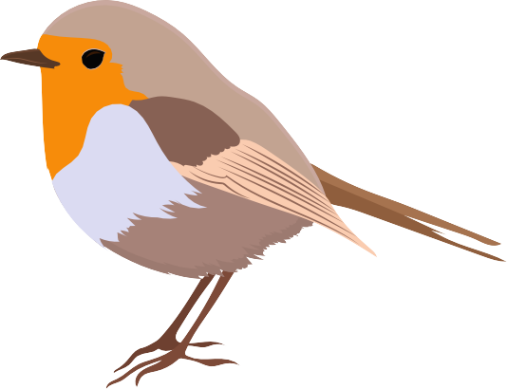

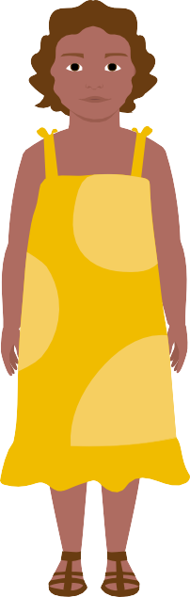

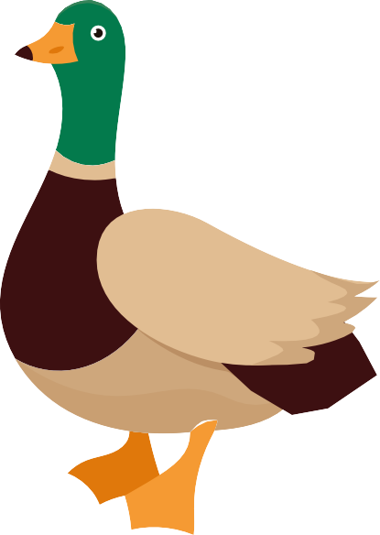

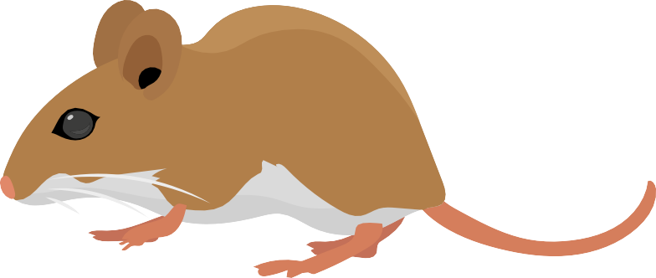

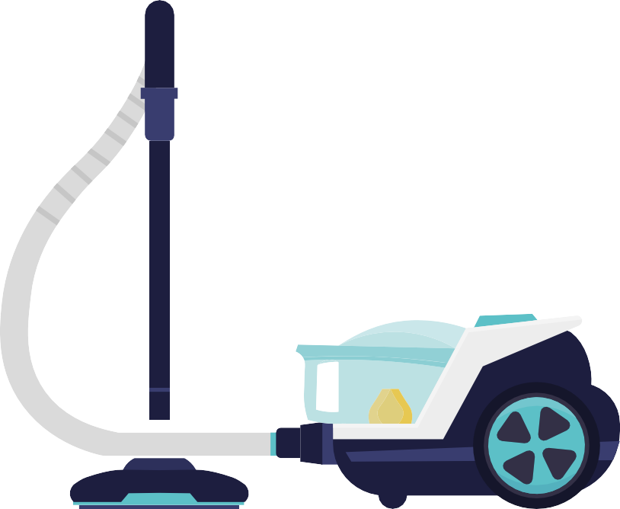

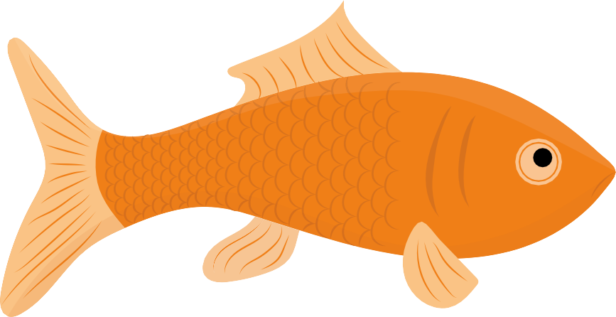
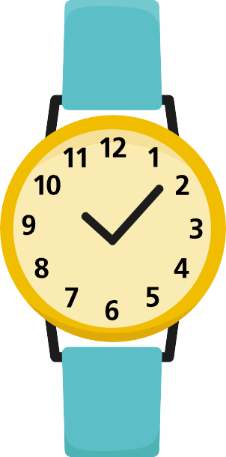

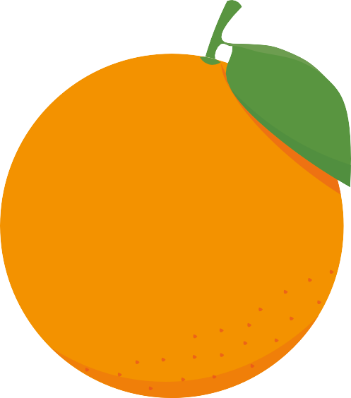

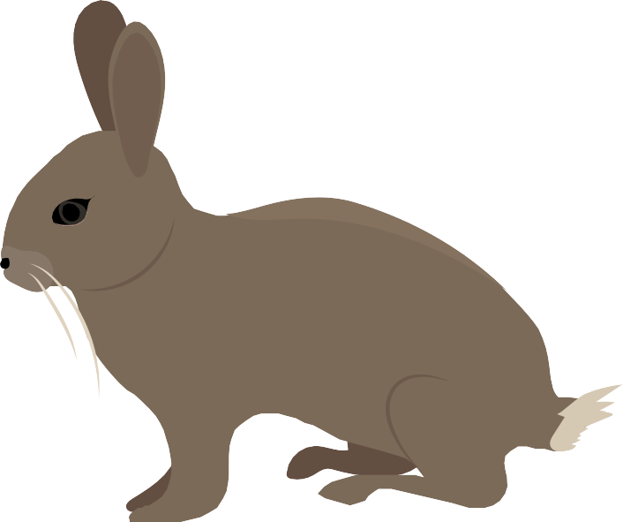

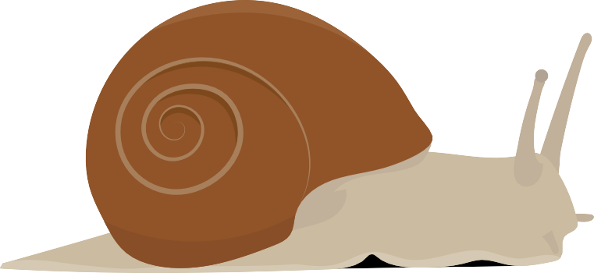

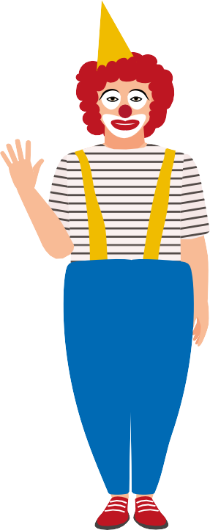

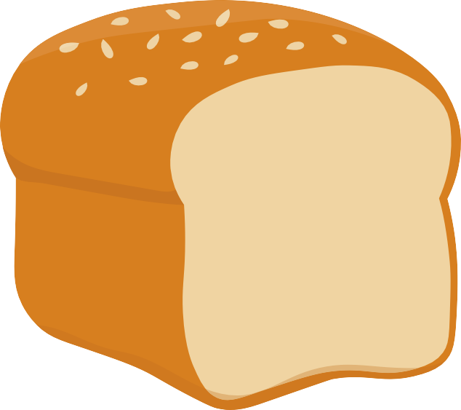

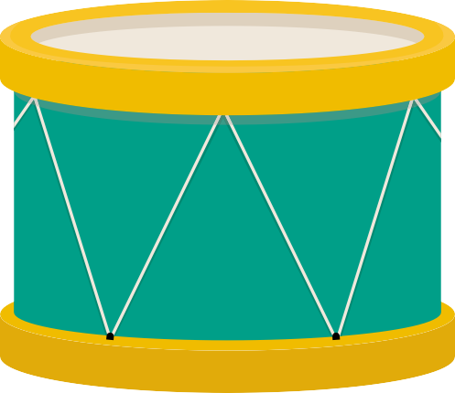
THINGS TO CONSIDER

What sounds can the child use?

What sounds is the child unable use, and what age should these be established?

Can they copy the sounds they aren’t using yet in isolation?

Visit our website at

Children's Speech and Language Therapy Service Leicester, Leicestershire and Rutland | Leicestershire Partnership NHS Trust (leicspart.nhs.uk)

Leicestershire Partnership NHS Trust
Bridge Park Plaza
Bridge Park Road
Thurmaston
LE4 8PQ
Tel: 0116 295 5256
www.leicspart.nhs.uk

© Speech Screen created by Northamptonshire Healthcare NHS Foundation Trust with permission to share and use within Leicestershire Partnership Trust

Review date: July 2025

