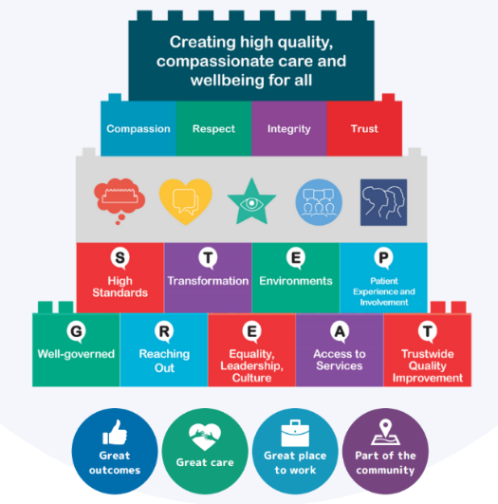
Leicestershire Partnership NHS Trust Risk Appetite Statement 2024/25
Our overarching vision is to provide high quality compassionate care and wellbeing for all. We have been delivering our five-year ‘Step up to Great’ strategy since 2020 and we are currently in our last year before we refresh our approach.
Our Board Assurance Framework (BAF) provides the key risks to achieving this strategy, structured by our four key strategic goal areas; these have also been applied to our risk appetite matrix to ensure alignment between our strategy and our approach to managing risk.
Risk Appetite is the amount and type of risk that an organisation is willing to take to meet their strategic objectives. Our Trust Board determines its level of risk appetite each year; this is applied to the Board Assurance Framework and is utilised during decision making discussions as part of our approach to managing risk in our everyday life.
The Trust Board has agreed an open appetite for risk. This means that we have a willingness to make decisions which may impact on our current business as usual for longer term reward and improvement if appropriate controls are in place. This is applied to all areas of risk type and across all four strategic goal areas. The definition of an open approach is provided by each area of risk type and strategic goal in the next section.
The Board recognises that there have been appropriate times when a more cautious, or indeed a more eager appetite to risk taking has been applied to decision making, however these are the exception to the rule and have a clear rationale. On balance, when predetermining the level of risk we all align on an open approach.
To apply an open appetite to risk, we will require a focus on assurance over the strength of our existing internal control framework, as well as identifying and embedding any new controls. We continue to monitor these through mechanisms such as the annual Head of Internal Audit Opinion and the delivery of audit programmes which provide us with significant assurance over our controls.
Our risk appetite will be reviewed annually, or sooner if the Trust receives any significant third line of assurance feedback.
We use a risk tolerance score to translate and provide a practical application of risk appetite to the management and scoring of risk on our BAF. It measures the levels of risk taking acceptable to the Trust. Essentially, the lower the appetite, the more mitigation required to ensure sufficient controls are in place to manage the risk. The greater the risk appetite the more assurance we need against the existing controls. Confidence will be gained through appropriate controls being in place that positively affect outcomes and through assurance that the controls are operating effectively.
Appetite Level | None | Minimal | Cautious | Open | Eager
Tolerance | None | Low | Moderate | High | Significant
Risk Score | 0-3 | 4-8 | 9-11 | 12-15 | 16+

Risk Appetite Matrix 2024/25
Risk Level | None | Minimal | Cautious | Open | Eager
Risk Type
Quality and Safety | Zero appetite for any decisions with a high chance of an adverse or uncertain impact on patient safety, quality of care and outcomes for the patient. | Appetite for taking very limited clinical risks if essential to patient care and outcomes. Such risks are properly assessed with mitigating controls in place. Avoid innovation unless established and proven to be effective. | Appetite for taking moderate clinical risks where there is a low degree of inherent risk and the possibility of improved outcomes, and appropriate controls are in place. | We will pursue innovation where there is potential for significant longer-term rewards and improvement on quality and safety outcomes. | We seek to lead the way and will prioritise new innovations, even in emerging fields. We consistently challenge current working practices in order to drive improvement in quality and safety outcomes.
Finance | No appetite for decisions or actions which may result in financial loss. | Only prepared to accept minimal possibility of material financial impacts or losses or reporting misstatements if essential to safe and effective patient care and outcomes | Limited financial impacts or losses are accepted if they yield upside opportunities elsewhere within the Trust. Value for money is a key focus. | Prepared to invest and/or accept financial impacts or losses for the benefit of improved patient care and outcomes if appropriate controls are in place and value for money is delivered. | Proactively invest and/or accept financial impacts or losses for the benefit of patient care and outcomes, recognising that the potential for substantial gain outweighs inherent risks.
Performance | No appetite for action which may impact on operational service delivery. Focus on capability to protect services and maintain tight control. | Limited action may be taken which may impact on operational service delivery only where it is essential to deliver safe and effective patient care and outcomes. Decision making authority held by senior management. | Appetite for taking moderate risks relating to service delivery where there is a low degree of inherent risk and the possibility of improved outcomes, and appropriate controls are in place. Robust performance oversight processes in place. | Willing to take decisions that will impact on the business-as-usual delivery of services to deliver transformation and secure longer term quality improvement. | Appetite to take investment and transformation decisions in areas which are likely to impact on the delivery and accessibility of services in the short term in order to deliver significant improvement for the long term.
People and Culture | Avoidance of any  workforce risks that  threaten the delivery of safe  and effective patient care and  outcomes. | Only prepared to accept the possibility of very limited workforce risk impacts if essential to safe and effective patient care and outcomes. Innovation is not a priority. | Prepared to take limited risk with regards to workforce as long as this could yield opportunities elsewhere within the Trust for improvements in workforce, cultural and leadership development. | Appetite to take workforce management decisions which may have short term implications for our workforce for potential longer-term gains. | Seek to lead the way in terms of workforce and cultural innovation, accepting that this may be disruptive in the short term, but would be outweighed by the opportunity to drive improvement.
External | Zero appetite for any decisions that present risks to the Trust maintaining its CQC registration, complying with the law and its policies. | Only prepared to accept the possibility of minor regulatory observations if related actions are essential to the safe and effective patient care and outcomes. | Accept possibility of moderate regulatory observations / judgements as long as appropriate controls are in place and there is a potential for improvement outcomes. | Willing to take decisions that are likely to bring additional scrutiny to outwardly promote new ideas and innovations where potential benefits outweigh the risks. | Comfortable to take decisions that may expose the trust to significant additional scrutiny or judgement as long as there is commensurate opportunity for improvement outcomes for our stakeholders.
Based on models produced by the Good Governance Institute ‘Risk Appetite for NHS Organisations, A matrix to support better risk sensitivity in decision taking’ developed in partnership with the board of Southwark Pathfinder CCG and Southwark BSU January 2012 and the Leeds Teaching Hospitals NHS Trust ‘Risk Appetite second edition’ March 2023

