Growing up with more than one language

Information for multilingual families

An Asian family - mother with two children 


Children’s Speech and Language

Therapy Service

Helping your child talk

Before babies are born they can hear your voice, so helping your child with their talking starts before birth.

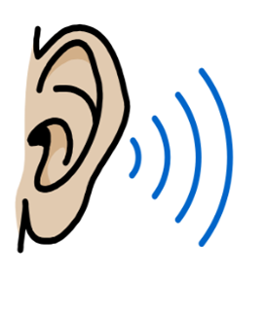

A collage of a person using a hammer and a person looking at a tree (with line of vision outlined)

Your child is going to learn language from you.

Talk about what you’re doing, what is happening and what you can see throughout the day in your home language.

The best way to help your child with their talking, is to talk to them in your most comfortable language. This means you are providing the best model of language as you will use a variety of words and form clear sentences.

A stick figure singing with hands up



Sing action songs and nursery rhymes in your home language with your child.

Share any picture books using A book with pictures of animals and a ball
your home language to talk about what is happening in the book.

Why growing up learning more than one language is good



It helps your child to value and share your culture and traditions.

A group of people with different skin tones and abilities


It helps your child communicate with their wider family and community.



It will have a positive influence on your child’s life.

A picture of a person thinking and three figures demonstrating the growth from baby, through childhood to adult



It helps your child’s thinking and learning as they grow.

Remember

your child will learn much better from play and talking with you, than from any

screen time or

electronic

devices.

Remember, learning language

is fun!

Over 70% of the world’s population speak more than one language!

Learning English

will be easier for your child if they are confident with your home language.

Useful Websites

<https://www.literacytrust.org.uk/early-years/bilingual-quick-tips>

<https://healthforunder5s.co.uk>

<https://www.bbc.co.uk/tiny-happy-people>

<https://www.multilingual-matters.com>

Date implemented: Month year

Last review: Month year

Review date: (maximum of two years from last reviewed)

Leaflet No. e.g. CHS/MSK/01 Edition (1, 2, 3, etc - new edition every change)